**INSTALLING ODI 12C IN STANDALONE MODE**

*by*[*Paul Cannon*](http://www.redstk.com/author/paulcannon/)*on 29th April 2014*[*18 comments*](http://www.redstk.com/installing-odi-12c-in-standalone-mode/#comments)

A few months back I blogged on how to install ODI 12c in a [standard enterprise environment](http://www.redstk.com/odi12c-installation-from-an-owb-developers-view/), but since then I’ve also installed it in standalone mode which is perfect for a single-user off-line development environment (my laptop!).

So here I’ll go through the steps of this mode of installation, including how to automate the starting of the agent.

As this is on a laptop, it’s a windows installation. Installing on Linux is virtually identical, but with .sh scripts in place of .cmd script and of course my automation of the starting of the agent could easily be replicated in a linux shell script to.

Note: The installation below will create two oracle homes, one for ODI itself and one for the Agent. For notation I’ll refer to them as <ODI_HOME> and <AGENT_HOME>.

**Pre-Requisites**

In standalone mode there is no weblogic server. ODI runs by itself, whilst the weblogic node manager (included in the ODI install files) is used to manage the running of the agent. So there is no need to download a weblogic install set.

Before installing ODI you must have a database installed. If you will always be running ODI on a network this can be on any connected server. If you plan to run ODI off-line on a laptop then obviously you need the database installed locally as well. I’m not covering how to do that in this blog – there are plenty of instructions on the web on how to do it. The database can be Oracle, SQL Server, MySql or DB2. In this instance I’m using Oracle 12c.

The database is primarily required for the ODI repositories, but obviously can also be used to populate data using ODI! No special database features are required for ODI but you can include whatever features you need for your ODI project.

ODI 12c itself is installed from the same file set as when performing an standard enterprise install, so download and unzip ofm_odi_generic_12.1.2.0.0_disk1_1of1.zip from technet. This creates the install file odi_121200.jar

You need a JDK installed before you start. My laptop already had JDK 7u55. Also check that the JAVA_HOME environment variable is set (this is not done by the JDK installer). It’s not compulsory but saves some typing later on.

[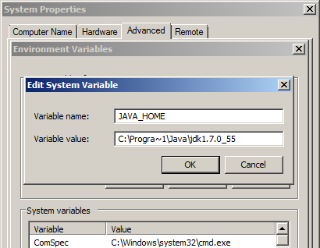](http://blog.3sixty-analytics.com/wp-content/uploads/2014/04/ODI_StandAlone1.png)

Note: use the short name for Program Files: “Progra~1”, the space between “Program” and “Files” will cause problems when running some of the java components later on.

**How to install ODI 12c**

Now we can start the ODI installation. We will need to run the installer twice. The first will install the basic ODI components which are required however you install ODI. Then since we do not have a weblogic server for the Agent we need to run the installer a second time to install the stand-alone agent components.

The installation requires a temporary directory. In windows this can simply be c:temp. Create a temporary directory if you don’t have one.

Now open a command window , change directory to where you unzipped odi_121200.jar above and enter the following command, altering the java path and temp directory to suite your environment:

"C:Program FilesJavajdk1.7.0_55binjava" -Djava.io.tmpdir=c:temp -jar odi_121200.jar

[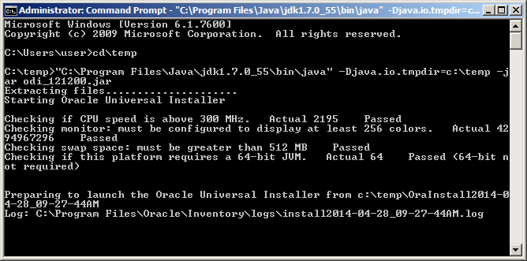](http://blog.3sixty-analytics.com/wp-content/uploads/2014/04/ODI_StandAlone2.png)

After a few seconds the installer will launch. Click next past the welcome screen:

[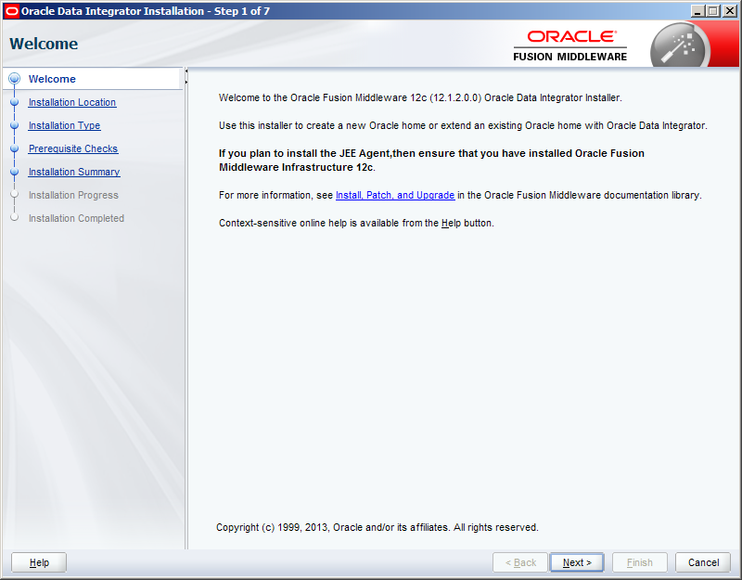](http://blog.3sixty-analytics.com/wp-content/uploads/2014/04/ODI_StandAlone3.png)

The Oracle Home defaulted to c:oracleMiddlewareOracle_Home. Since I already had an oracle home under c:app with the oracle database in it, I changed the home to the same root folder:

[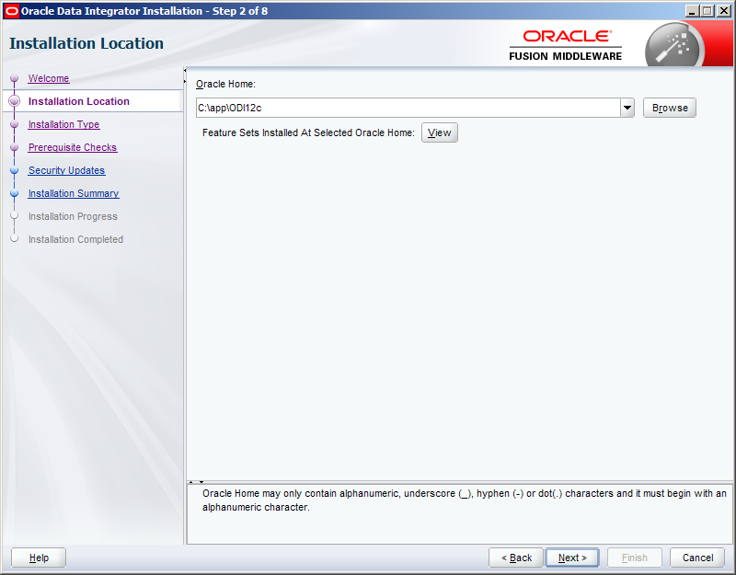](http://blog.3sixty-analytics.com/wp-content/uploads/2014/04/ODI_StandAlone4.png)

In the Installation Type screen select ‘Enterprise installation’. This will install the main ODI software required regardless of the installation type.

[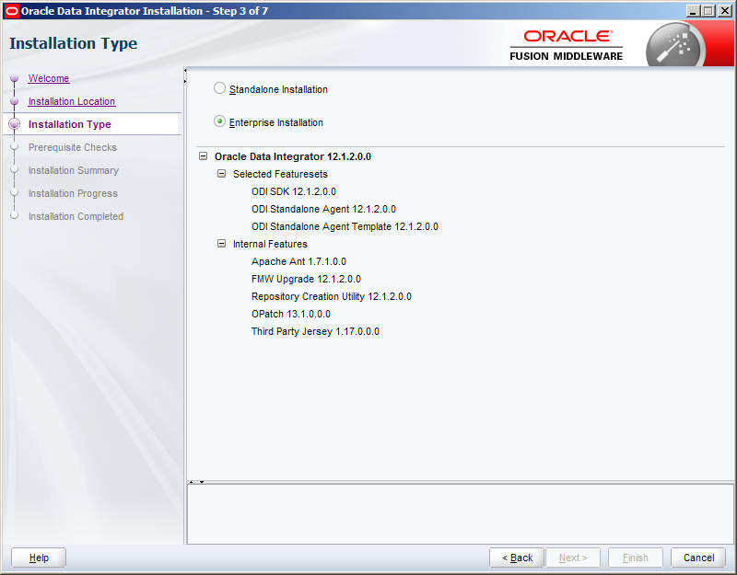](http://blog.3sixty-analytics.com/wp-content/uploads/2014/04/ODI_StandAlone5.png)

Confirm the prerequisites pass ok:

[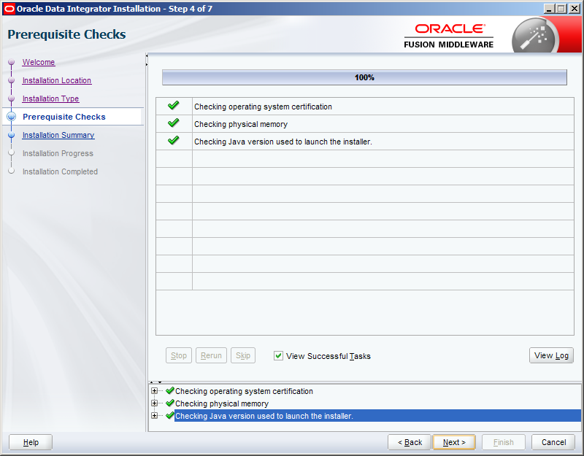](http://blog.3sixty-analytics.com/wp-content/uploads/2014/04/ODI_StandAlone6.png)

Check the Installation Summary (a little pointless in this case, we’ve hardly had to select much!):

[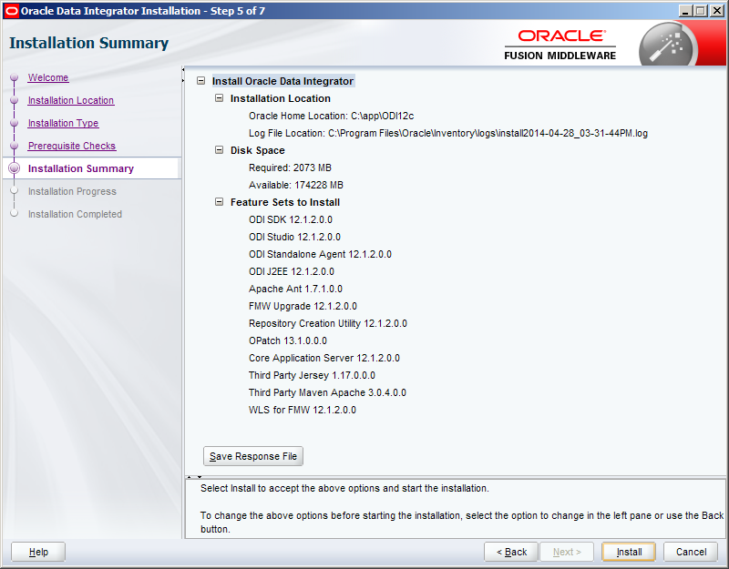](http://blog.3sixty-analytics.com/wp-content/uploads/2014/04/ODI_StandAlone7.png)

Let the installation proceed:

[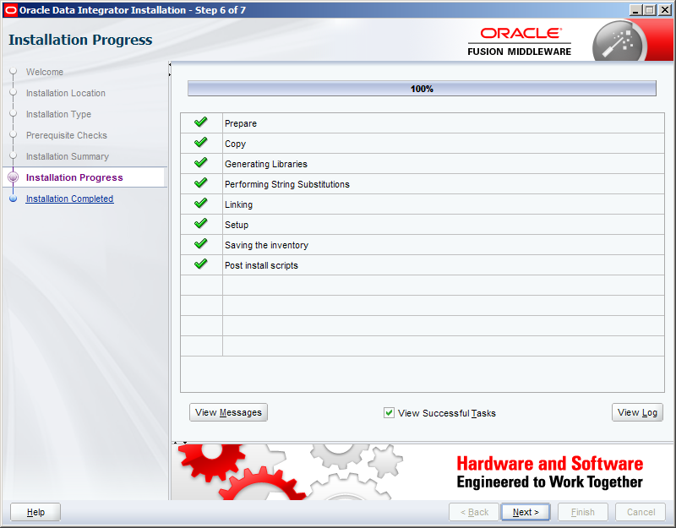](http://blog.3sixty-analytics.com/wp-content/uploads/2014/04/ODI_StandAlone8.png)

And finally confirm the installation completed successfully. The installer will close when you click Finish.

[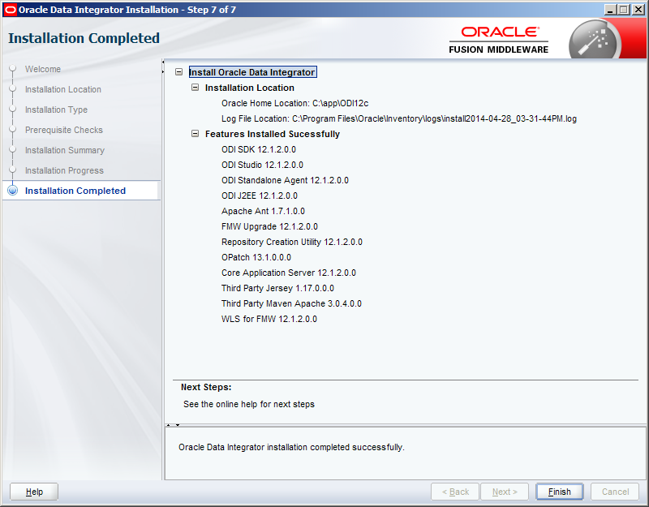](http://blog.3sixty-analytics.com/wp-content/uploads/2014/04/ODI_StandAlone9.png)

Now run the installer a second time using the same command as above and click past the welcome screen again.

This time we are going to perform the standalone installation for the Agent. The Agent must be installed in a different Oracle Home to the main enterprise installation above, so enter a different path:

[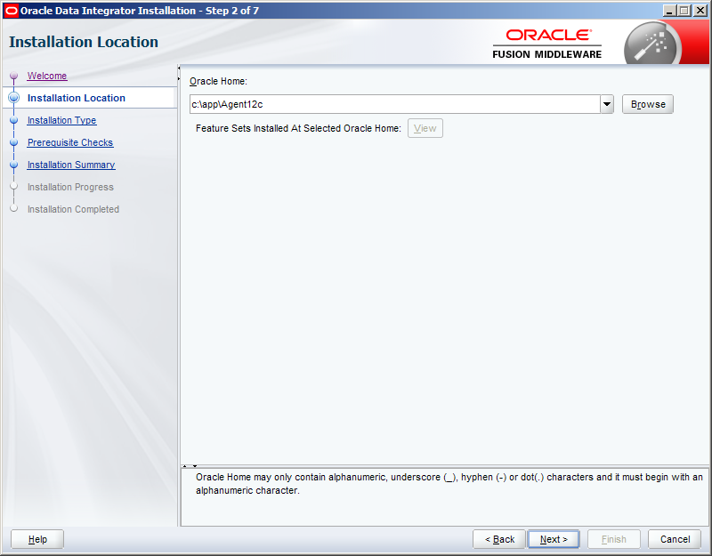](http://blog.3sixty-analytics.com/wp-content/uploads/2014/04/ODI_StandAlone10.png)

In the installation type screen choose Standalone installation:

[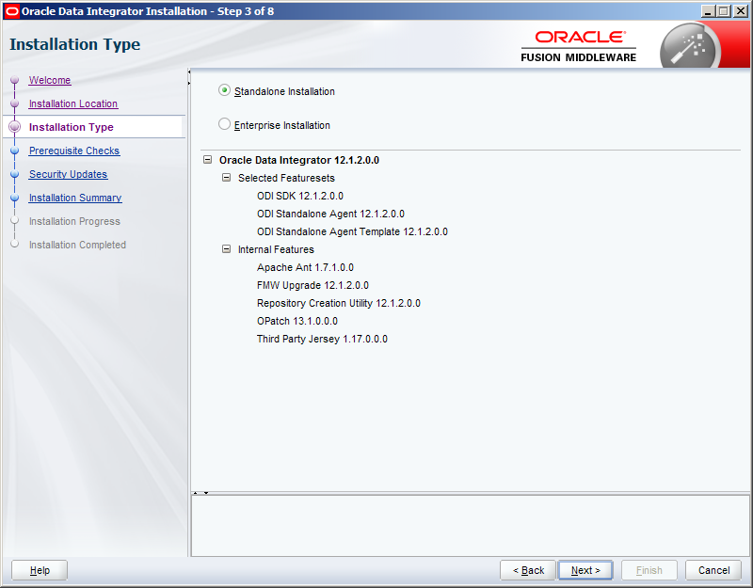](http://blog.3sixty-analytics.com/wp-content/uploads/2014/04/ODI_StandAlone11.png)

Then click past the prerequisite checks screen. (I’ve never seen the pre-reqs for the standalone fail when enterprise pre-reqs passed!).

As you are now performing a stand-alone installation, as opposed to an installation into other installed software (Weblogic server), the installer asks if you want to be kept informed about software security updates. The choice is yours, as this is just a local dev installation I’d decided not received the emails:

[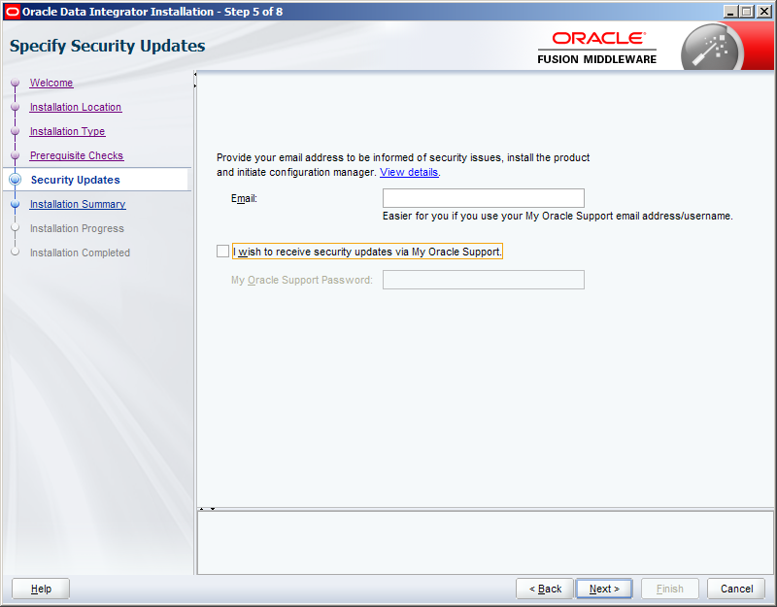](http://blog.3sixty-analytics.com/wp-content/uploads/2014/04/ODI_StandAlone12.png)

Upon clicking next you will then be taken through the installation summary & progress screens, finally ending up at the completed screen:

[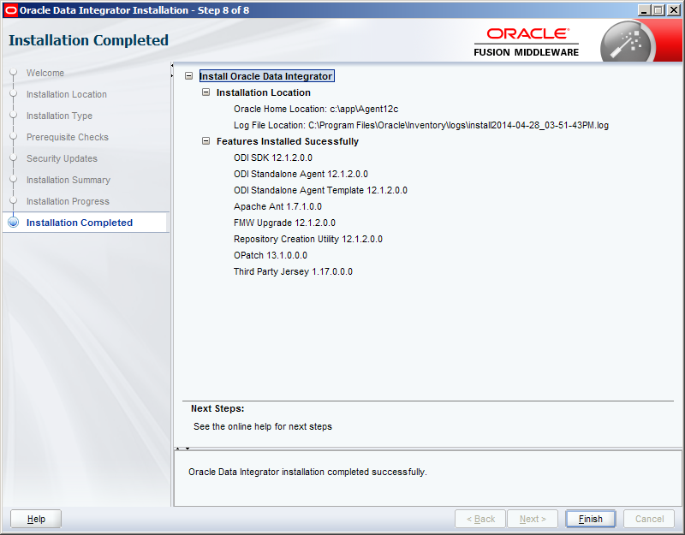](http://blog.3sixty-analytics.com/wp-content/uploads/2014/04/ODI_StandAlone13.png)

**Creating the ODI Repositories**

ODI requires two repositories – a Master repository, containing global configuration details, such as security, and a Work repository, containing the actual ETL projects you build.

The repositories are created with the Repository Creation Utility (RCU) which is located within the <ODI _HOME>.

Go to the <ODI_HOME>oracle_commandbin directory and run rcu.bat:

[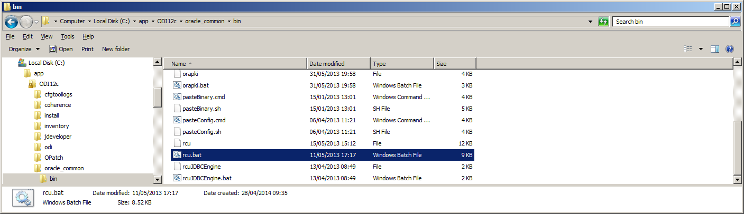](http://blog.3sixty-analytics.com/wp-content/uploads/2014/04/ODI_StandAlone14.png)

This opens the RCU. Click past the welcome screen:

[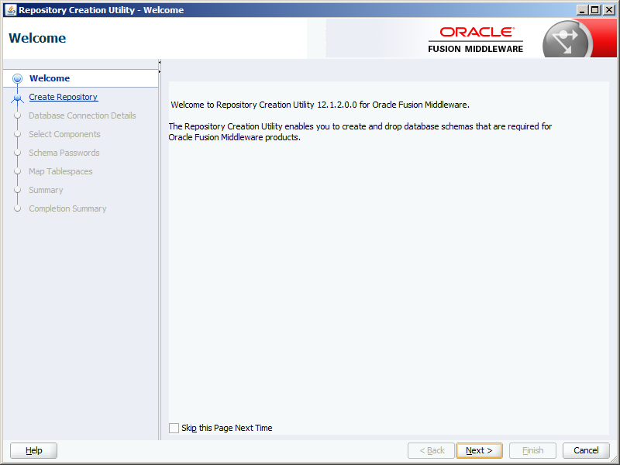](http://blog.3sixty-analytics.com/wp-content/uploads/2014/04/ODI_StandAlone15.png)

You are now asked what you wish to do. In this case we want to create a new repository and do it now. So select ‘Create Repository’ and ‘System Load and Product Load’.  If you are installing the repositories in a server based database and require a DBA to do this you can use the ‘Prepare Scripts’ option instead.

[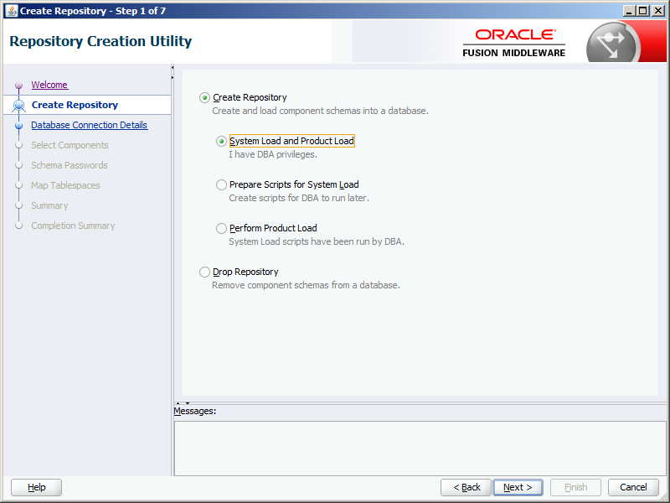](http://blog.3sixty-analytics.com/wp-content/uploads/2014/04/ODI_StandAlone16.png)

I’m creating the Repository now, so next the database connection details are required, including a user with DBA privilege:

[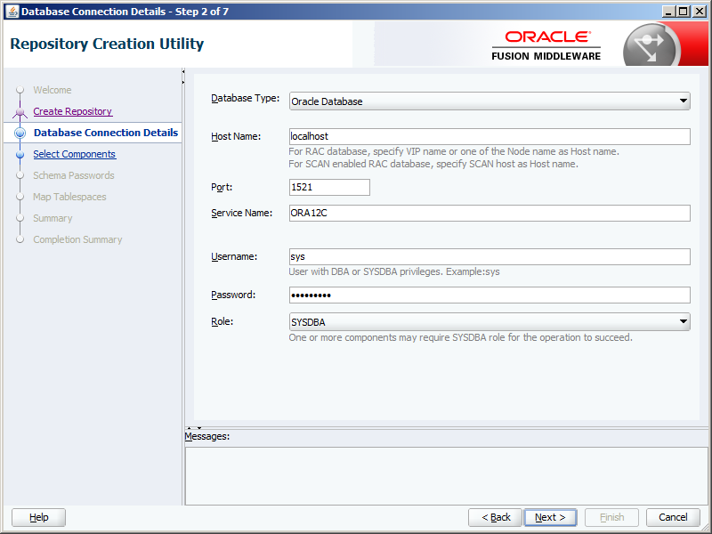](http://blog.3sixty-analytics.com/wp-content/uploads/2014/04/ODI_StandAlone17.png)

The RCU will check the details entered:

[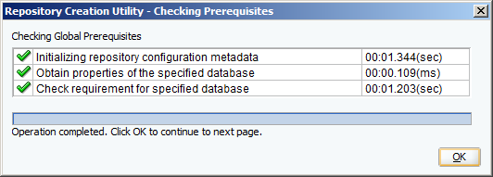](http://blog.3sixty-analytics.com/wp-content/uploads/2014/04/ODI_StandAlone18.png)

You now need to select the components to create the repository for.   ‘AS Common Schemas’ are compulsory and already selected. All we need to do is select ‘Oracle Data Integrator’ – ‘Master and Work Repository’ will be auto-selected.

You can also choose a prefix for the schema owner. It defaults to DEV, which is fine for me. Make a note of the schema owner – DEV_ODI_REPO in this case, you will need it later.

[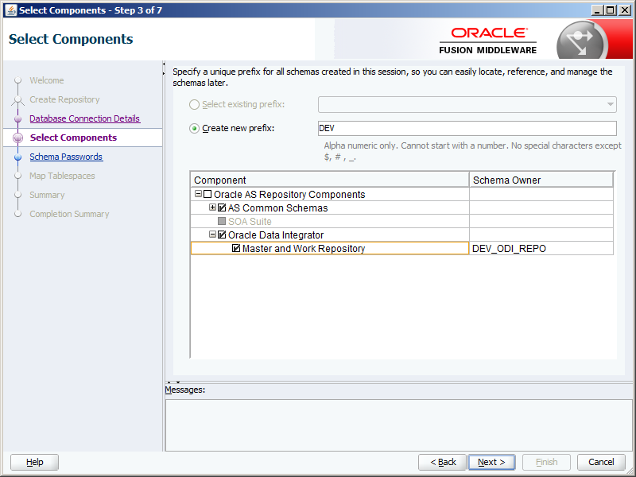](http://blog.3sixty-analytics.com/wp-content/uploads/2014/04/ODI_StandAlone19.png)

Some more checks are carried out:

[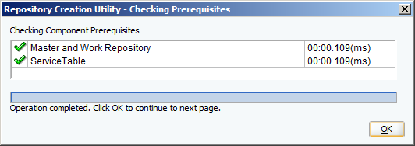](http://blog.3sixty-analytics.com/wp-content/uploads/2014/04/ODI_StandAlone20.png)

You now need to enter a password for the schema owner – this is only one schema, so select ‘Use same passwords for all schemas’ and enter your password twice. Again you will need this later.

[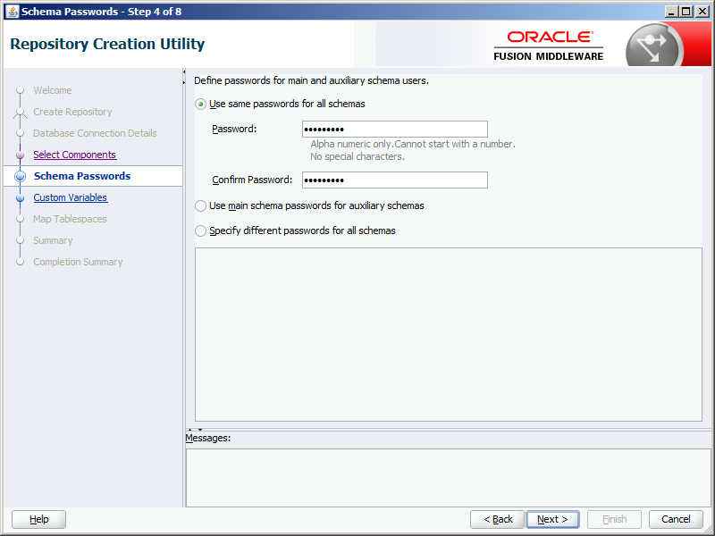](http://blog.3sixty-analytics.com/wp-content/uploads/2014/04/ODI_StandAlone21.png)

Now some additional details are required for the ODI repositories:

* Supervisor password (SUPERVISOR is the admin user in ODI)
* Work Repository Type – I chose Development  – D – (which allows execution as well)
* The Work Repository Name
* The Work Repository Password

Make a note of the details you enter, you will need them later.

[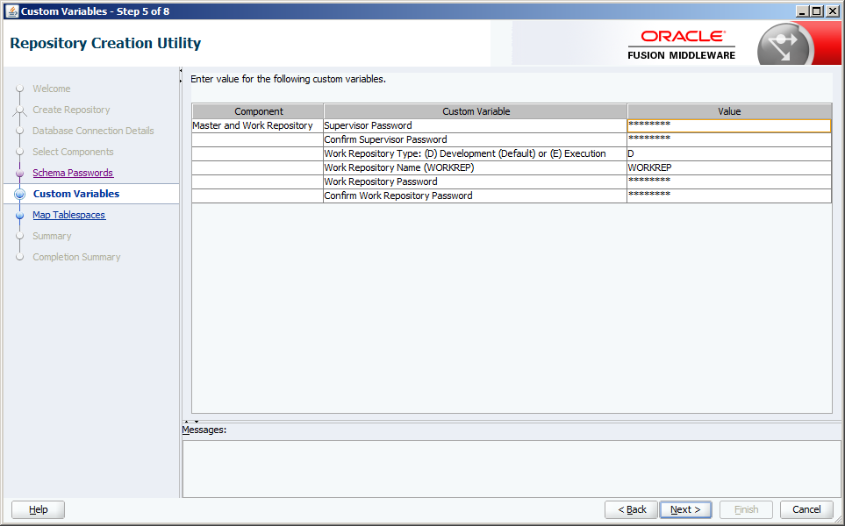](http://blog.3sixty-analytics.com/wp-content/uploads/2014/04/ODI_StandAlone22.png)

At this point (if the database is Oracle) you can choose which tablespaces create the repositories in. The RCU will fill in default values and I had no reason to change them. If you are installing the repositories in a server database the DBA’s may have preferences they wish you to use. Click on the ‘Manage Tablespaces’ button if you need to do this.

[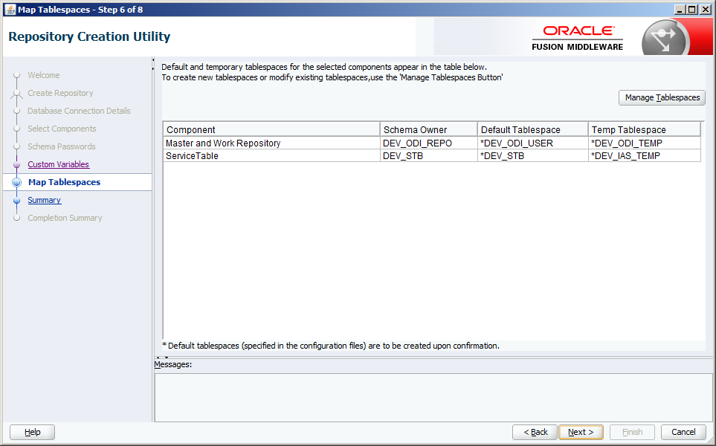](http://blog.3sixty-analytics.com/wp-content/uploads/2014/04/ODI_StandAlone23.png)

You will get a warning that the tablespaces don’t exist and will be created if you continue:

[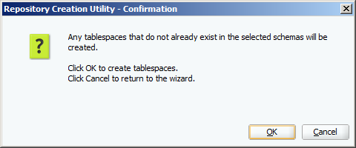](http://blog.3sixty-analytics.com/wp-content/uploads/2014/04/ODI_StandAlone24.png)

Let the tablespaces be created:

[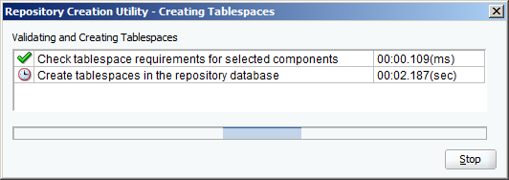](http://blog.3sixty-analytics.com/wp-content/uploads/2014/04/ODI_StandAlone25.png)

Finally the RCU is ready to build the repositories. Click Create to start:

[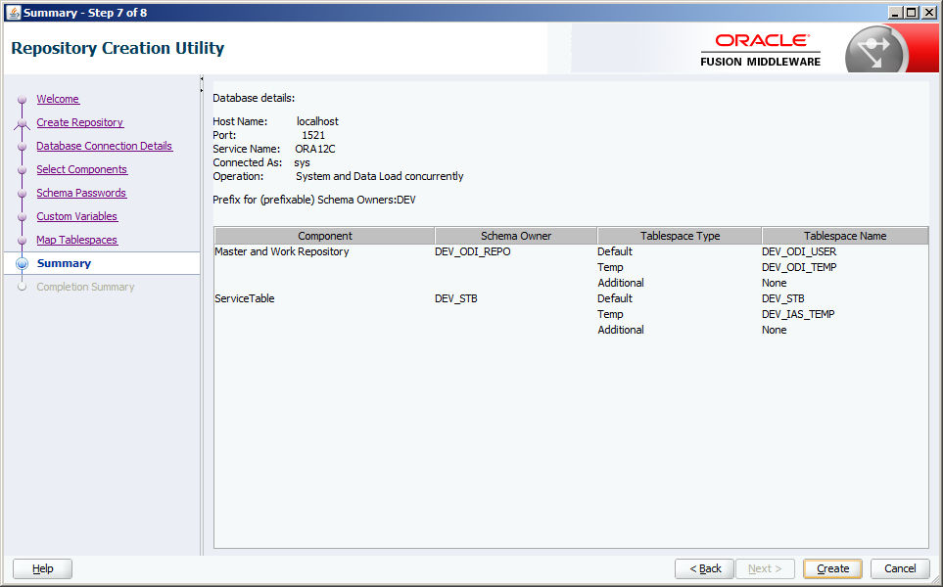](http://blog.3sixty-analytics.com/wp-content/uploads/2014/04/ODI_StandAlone26.png)

This will take a few minutes and all being well you will get a successful completion screen:

[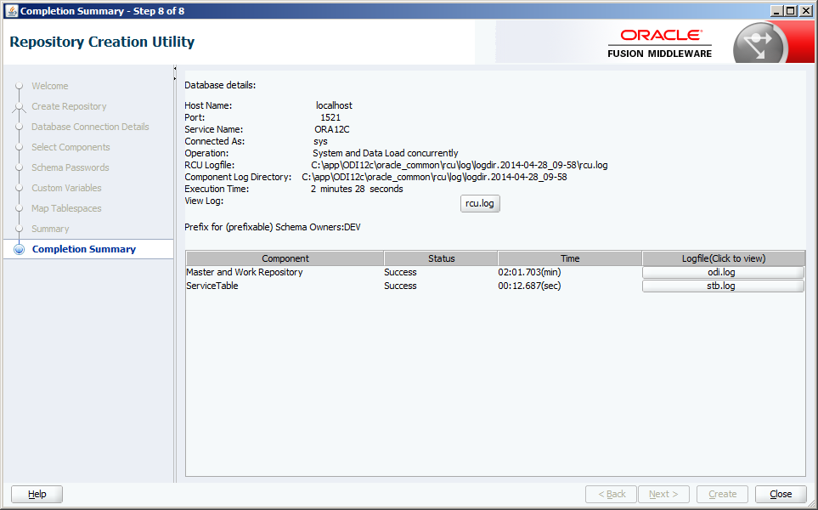](http://blog.3sixty-analytics.com/wp-content/uploads/2014/04/ODI_StandAlone27.png)

Click ‘Close’ to shut down the RCU.

**Creating a Domain for the Standalone Agent**

As this is a standalone installation we now need to setup the Agent process. The weblogic node manager will be used for this and a couple of command files will be created which need to be run to start up the agent whenever you want to use it – to replace the none-existent weblogic server.  Later on I’ll show how this can be simply automated in a windows environment.

The first step though is to run the agent configuration wizard. This is located in the <AGENT_HOME> directory.

Go to the <AGENT_HOME>oracle_commandcommonbin directory and run config.cmd.

The Wizard will load and start you off in the configuration type screen.

Ensure ‘Create a new domain’ is selected and check the domain location – this can be left as the default <AGENT_HOME>user_projectsdomainsbase_domain or changed as required – I’ve given mine a slightly more useful name:

[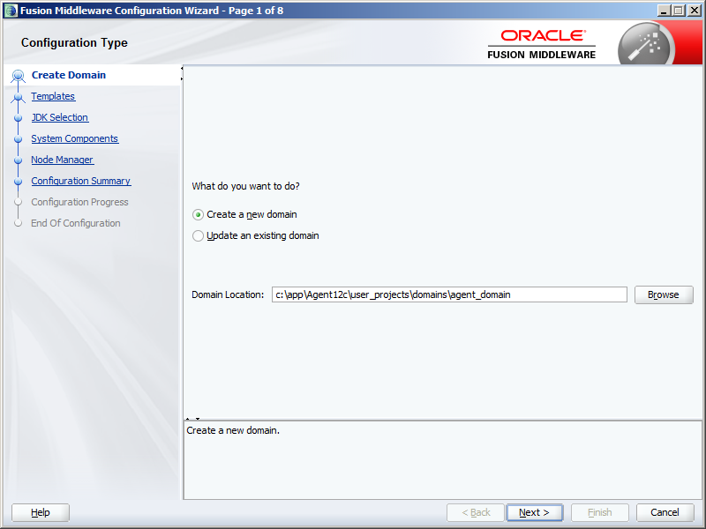](http://blog.3sixty-analytics.com/wp-content/uploads/2014/04/ODI_StandAlone28.png)

In the templates screen you have to select the template for the Agent. There is only one – ‘Oracle Data Integrator – Standalone Agent – 12.1.2.0 [odi]’, so select it:

[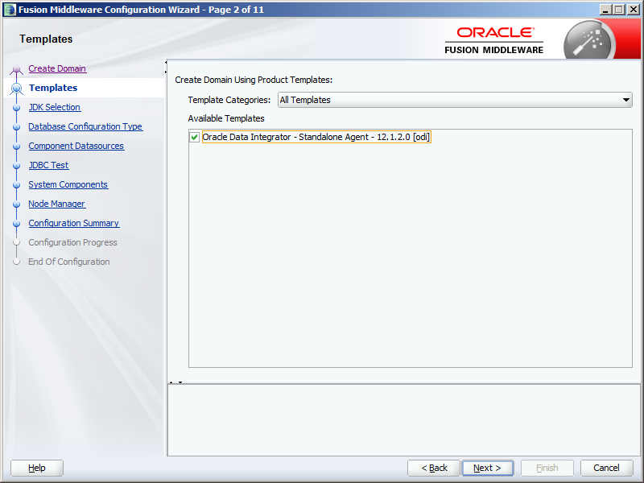](http://blog.3sixty-analytics.com/wp-content/uploads/2014/04/ODI_StandAlone29.png)

Next you need to specify the Java JDK to use. If you set the JAVA_HOME environment variable it should default to this, otherwise you will need to enter it.  Be warned, in a windows environment use the short directory name PROGRA~1 rather than ‘Program Files’ to remove the space:

[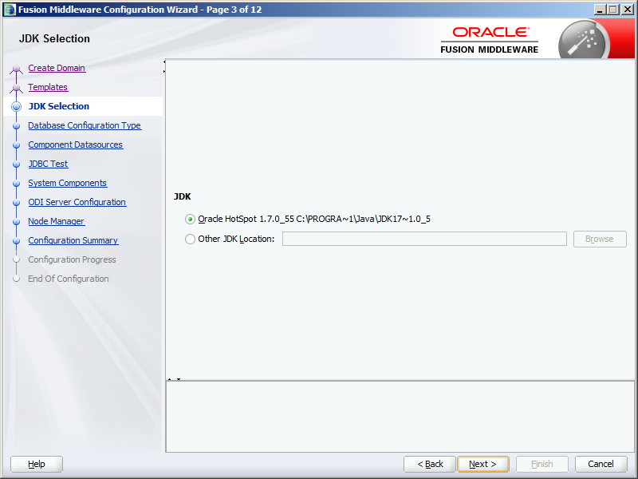](http://blog.3sixty-analytics.com/wp-content/uploads/2014/04/ODI_StandAlone30.png)

The wizard now need to retrieve the repository configuration from the database. Enter the connection details for the database as created using the RCU above. If you changed the schema owner prefix change the DEV_STB schema name appropriately.

Then click ‘Get RCU Configuration’ and wait for the details to be retrieved in the ‘Connection Result Log’ window. If you get any errors check your connection details and try again.

[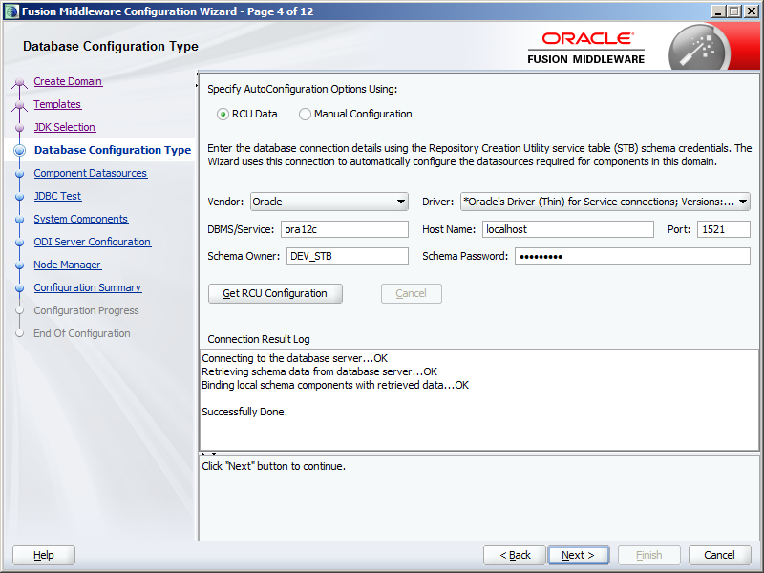](http://blog.3sixty-analytics.com/wp-content/uploads/2014/04/ODI_StandAlone31.png)

In the next screen you need to confirm the details are correct. As we created the schemas with the same password, the passwords will default to that entered in the previous screen. If the schemas have different passwords you will need to enter them here.

[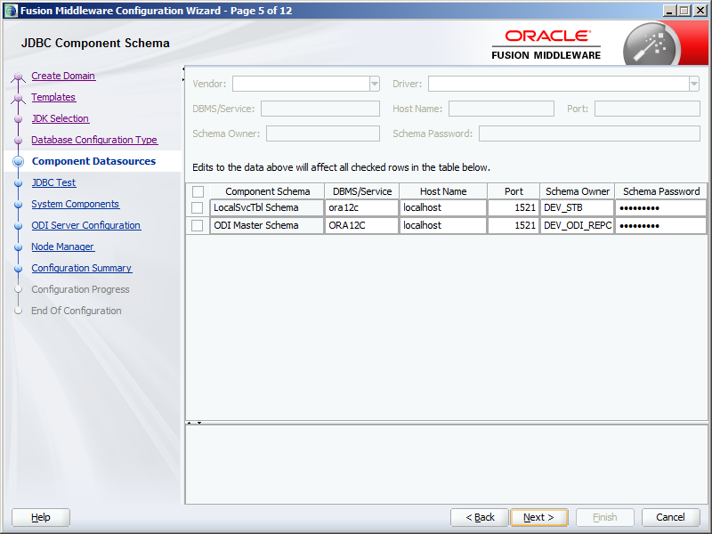](http://blog.3sixty-analytics.com/wp-content/uploads/2014/04/ODI_StandAlone32.png)

The wizard will then test the connection to these schemas and show the results of the test. Again if you encountered any errors go back, check the details and passwords and try again:

[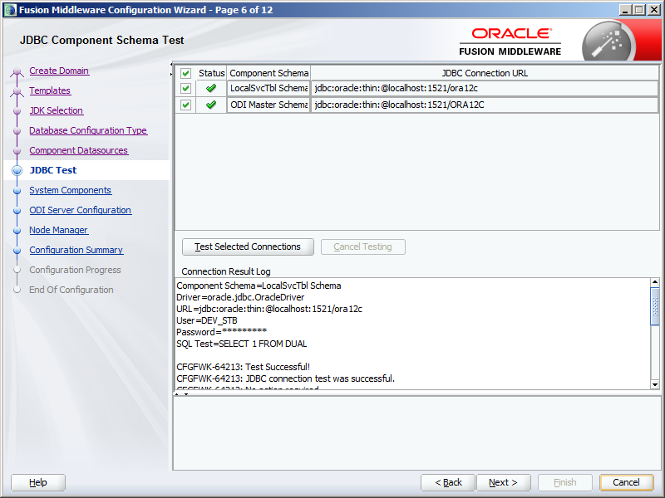](http://blog.3sixty-analytics.com/wp-content/uploads/2014/04/ODI_StandAlone33.png)

The System Components screen is where we specify the agent to be created. This will be populated as below by default and you shouldn’t need to change these values. Make a note of the System Component name – OracleDIAgent1 – this will be needed later.

[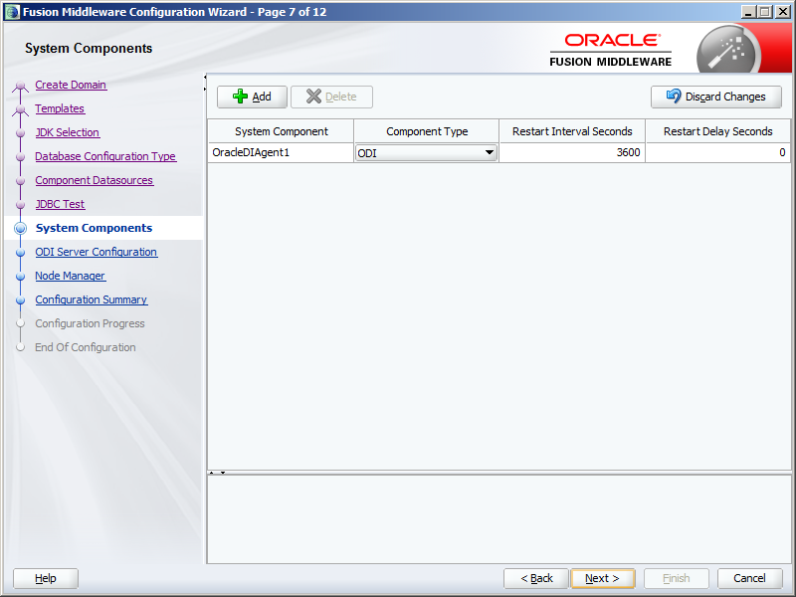](http://blog.3sixty-analytics.com/wp-content/uploads/2014/04/ODI_StandAlone34.png)

You must now specify the details for the Agent. Again this will be default populated – you only need to enter the SUPERVISOR password – which you created during the RCU install above. Make a note of the Server Listen Port number, you will need this later.

[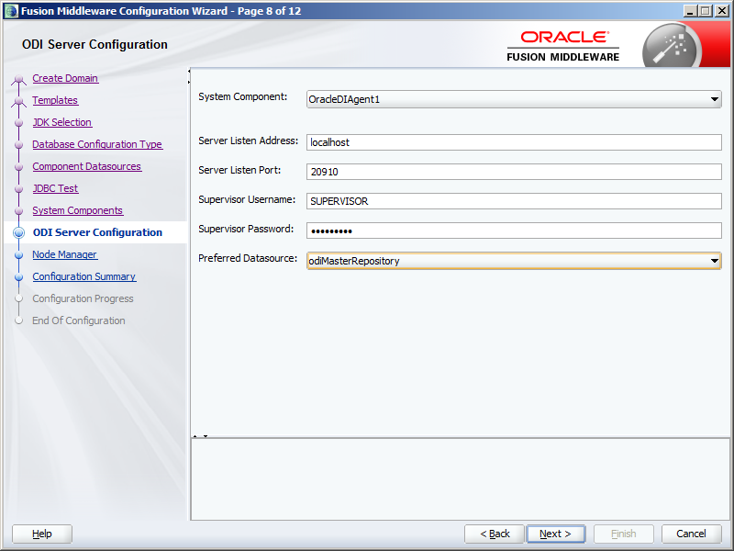](http://blog.3sixty-analytics.com/wp-content/uploads/2014/04/ODI_StandAlone35.png)

In the Node Manager screen choose ‘per domain’. The ‘Custom Location’ would be used in a server environment where a number of users share an Agent.

You need to create credentials for this Node Manager – which will be needed for when starting the Agent. Enter a suitable user-id and password – and take a note of them.

[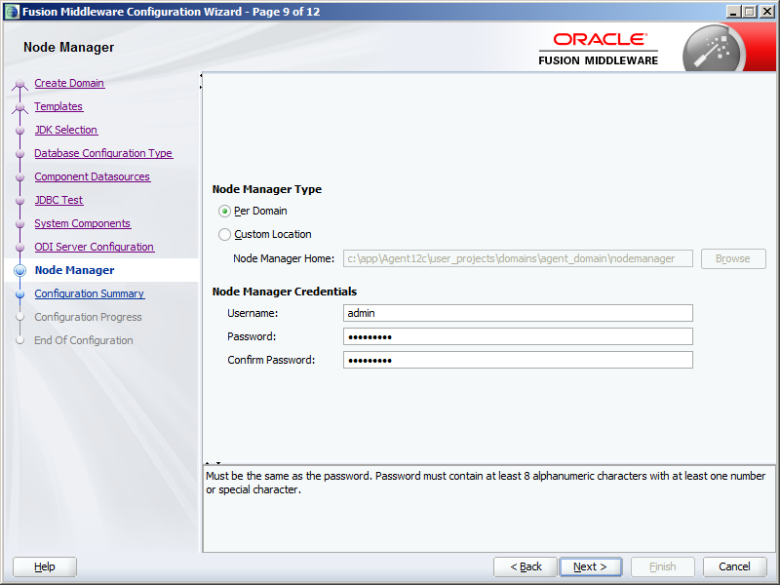](http://blog.3sixty-analytics.com/wp-content/uploads/2014/04/ODI_StandAlone36.png)

Finally confirm the configuration is correct before clicking ‘Create’:

[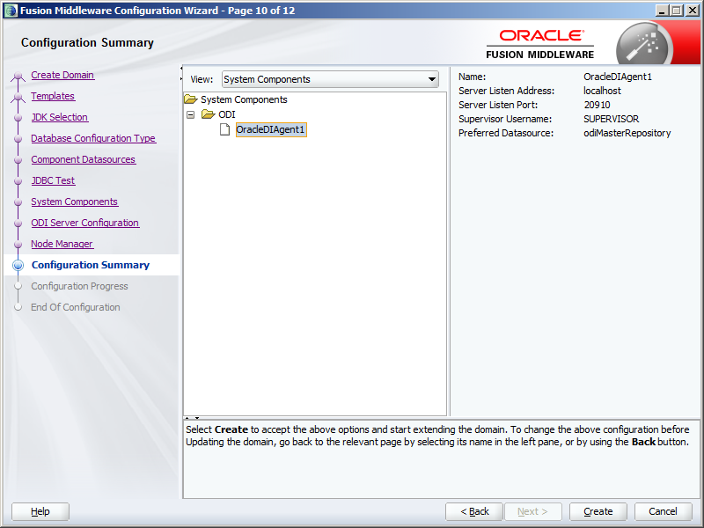](http://blog.3sixty-analytics.com/wp-content/uploads/2014/04/ODI_StandAlone37.png)

This configuration will only take a few seconds:

[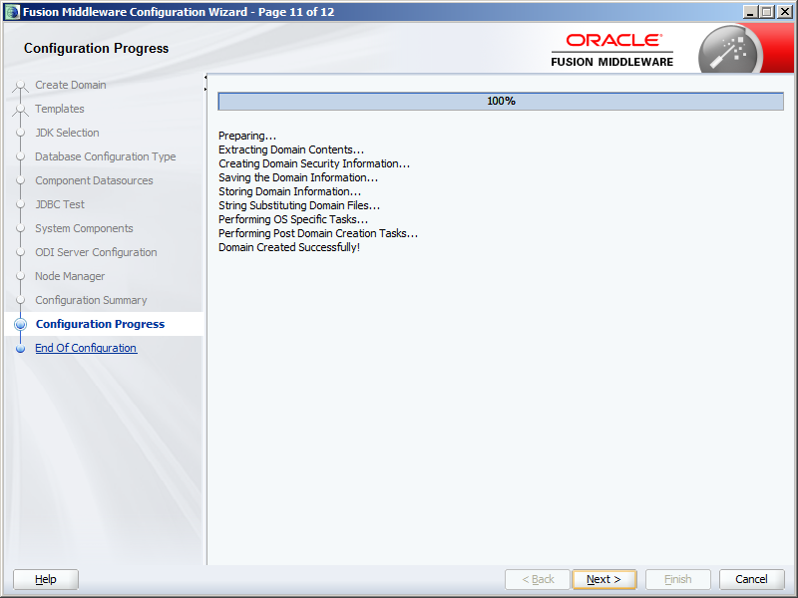](http://blog.3sixty-analytics.com/wp-content/uploads/2014/04/ODI_StandAlone38.png)

Finally take a note of the domain location (which is what you entered above):

[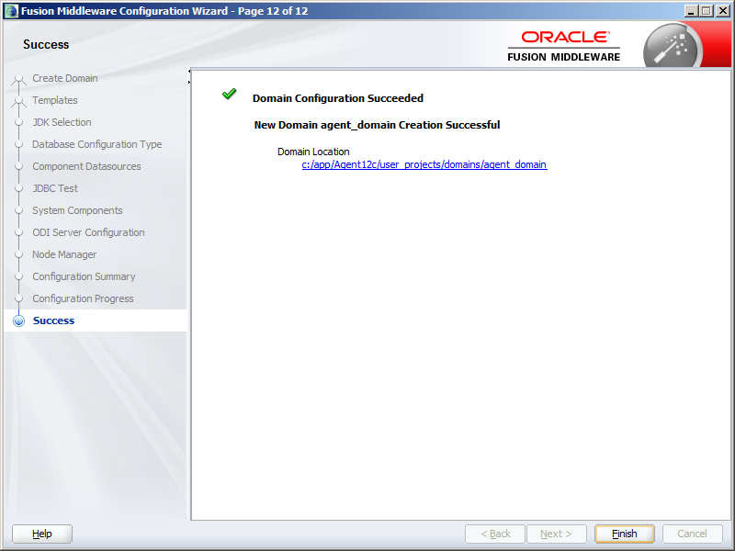](http://blog.3sixty-analytics.com/wp-content/uploads/2014/04/ODI_StandAlone39.png)

**Starting the Agent in ODI 12c**

To start the Agent two processes need to be kicked off:

* The Node Manager
* The Agent Process

To start the node manager, from the agent domain home run startNodeManager.cmd:

<AGENT_HOME>user_projectsdomainsagent_domainbinstartNodeManager.cmd

[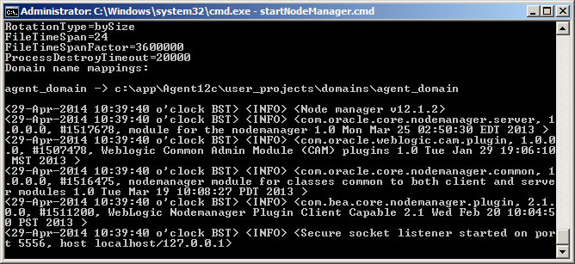](http://blog.3sixty-analytics.com/wp-content/uploads/2014/04/ODI_StandAlone40.png)

Minimise the command window that opens (do not close as this will shut down the node manager)

To start the agent, from the agent domain home run startComponent.cmd OracleDIAgent1

Do it from a command window:

<AGENT_HOME>user_projectsdomainsagent_domainbinstartComponent.cmd OracleDIAgent1

You will be prompted to enter the node manager password.

[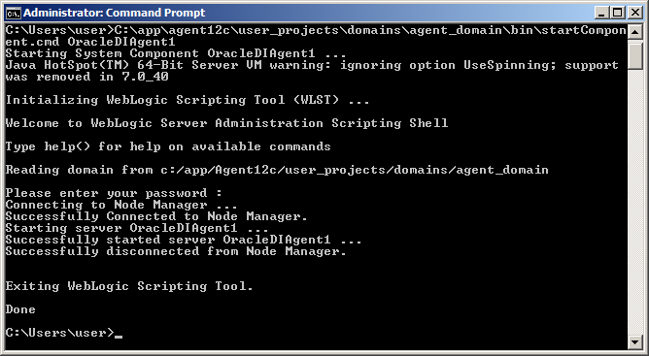](http://blog.3sixty-analytics.com/wp-content/uploads/2014/04/ODI_StandAlone41.png)

In this case the start process returns back to the command prompt, so you can close the window. If you look at the Node Manager command window you’ll see it now reports than OracleDIAgent1 is now running:

[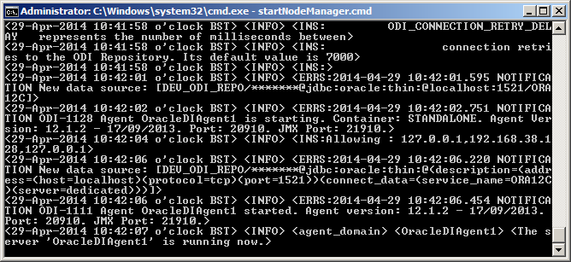](http://blog.3sixty-analytics.com/wp-content/uploads/2014/04/ODI_StandAlone42.png)

You can confirm this by entering the Agent URL into a brower. The URL will be: http://hostname:AgentListenPort/oraclediagent

e.g.:  http://localhost:20910/oraclediagent

and will return a <Ping/> tag if working correctly:

[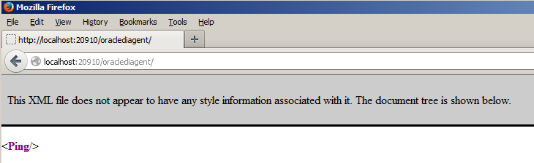](http://blog.3sixty-analytics.com/wp-content/uploads/2014/04/ODI_StandAlone43.png)

**Scripting the startup of the Node Manager and Agent**

You need to start the Node Manager and Agent everytime you need to use them. Not a problem on a server as you can just leave them running, but off-line, such as on my laptop, you’ll probably shut the computer down regularly and therefore need to restart the Node Manager and Agent.

It’s a simple task to script the running of these via some basic Windows batch functions.

Firstly we need to automate the entering of the Node Manager password. In the <AGENT_HOME>user_projectsdomainsagent_domainbin directory create a text file called properties.txt and into it enter the password for the Node Manager:

[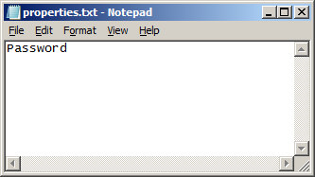](http://blog.3sixty-analytics.com/wp-content/uploads/2014/04/ODI_StandAlone44.png)

Now in the <AGENT_HOME> directory (or anywhere else that’s easy to locate) create a file called start_agent.bat.  Edit it and enter the following commands:

|  |
| --- |
| ping -n 20 localhost > nul  cd C:appAgent12cuser_projectsdomainsagent_domainbin  start /min startNodeManager.cmd  ping -n 20 localhost > nul  cd C:appAgent12cuser_projectsdomainsagent_domainbin  call startComponent.cmd OracleDIAgent1 <properties.txt  exit |

This calls the startNodeManager.cmd with the /min parameter so the command window is automatically minimised.

For startComponent.cmd the properties.txt file is used as an input file – this means that when startComponent.cmd pauses to wait for user input that input will be taken from the file, so the password will be entered automatically.  Not recommended for a production environment, or even an enterprise development environment, but perfect for an off-line standalone environment!

In between the startNodeManager.cmd and startComponent.cmd is a ping command. This just pauses the batch file giving the node manager time to start up before the agent is run.

In the next step I’m going to have this batch file run automatically when my laptop starts. This is what the first ping command is for. It pauses the running of the batch file to allow for other Windows services to start – if you have many other services on your computer, or it’s just a slow computer you may want to lengthen this delay by increasing the ‘–n 20’ option to a higher number.

Finally the ‘exit’ command closes the command window once the agent has started.

To have this batch file run automatically upon windows start-up simply copy it (or a shortcut of it) to your start-up folder.  From the start button select ‘All Programs’, then right click on Startup and select open and paste it into the explorer window, or go straight to the startup folder under C:Users*user-id*AppDataRoamingMicrosoftWindowsStart MenuProgramsStartup.

[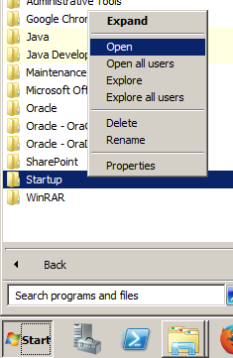](http://blog.3sixty-analytics.com/wp-content/uploads/2014/04/ODI_StandAlone45.png)

Now restart the computer. Once it has fully restarted you’ll have one minimised command window for the Node Manager, which if you look at should say ‘OracleDIAgent1’ is now running:

[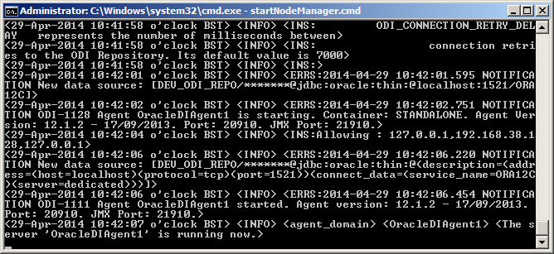](http://blog.3sixty-analytics.com/wp-content/uploads/2014/04/ODI_StandAlone46.png)

**Running ODI Studio for the first time**

The first time ODI is run a connection to the Master repository needs to be created, followed by the connection to the Agent.

The ODI installation does not automatically create a program group or any shortcuts – you can do this yourself if you want.

ODI Studio can be found in the <ODI_HOME>odistudio directory.  Choose odi.exe for 32bit Windows or odi64.exe for 64bit. (or odi.sh for Linux)

[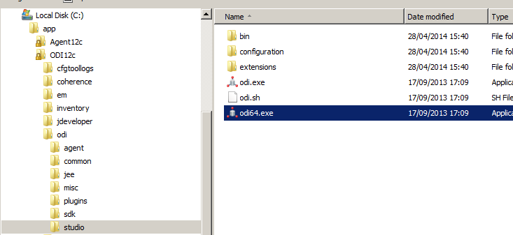](http://blog.3sixty-analytics.com/wp-content/uploads/2014/04/ODI_StandAlone47.png)

Upon first running Studio you will be prompted for the location of the Java JDK. This should default to the Java in your JAVA_HOME – although interestingly it’s happy about the space in ‘Program Files’ this time.  If no JDK is specified, click Browse to locate it.

[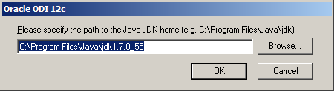](http://blog.3sixty-analytics.com/wp-content/uploads/2014/04/ODI_StandAlone48.png)

Then the funky splash screen appears…

[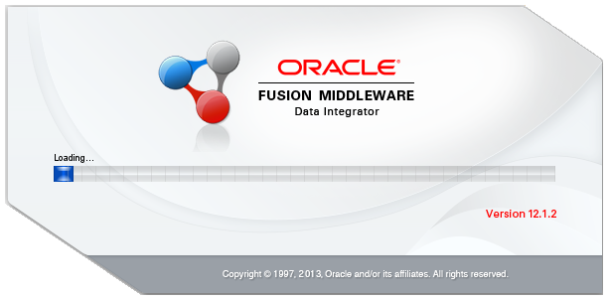](http://blog.3sixty-analytics.com/wp-content/uploads/2014/04/ODI_StandAlone49.png)

As this is a first-time run, it asks about importing preferences. I didn’t have previous installation to import from…

[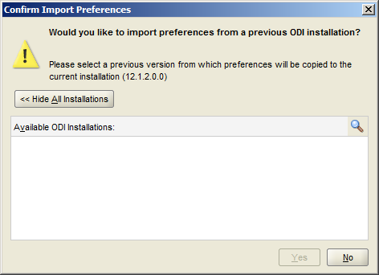](http://blog.3sixty-analytics.com/wp-content/uploads/2014/04/ODI_StandAlone50.png)

And then we are in ODI studio!

[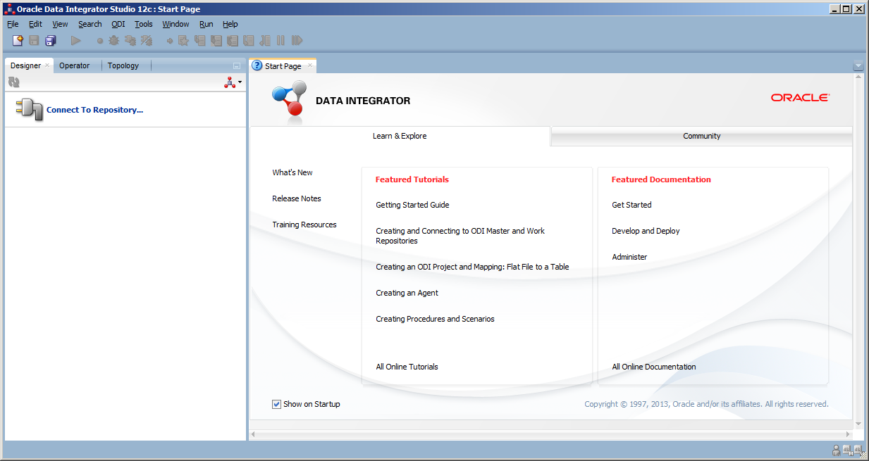](http://blog.3sixty-analytics.com/wp-content/uploads/2014/04/ODI_StandAlone51.png)

So the first job is to connect to the master repository.

From the menu bar, select File -> New

In the ‘New Gallery’ window,  click on the ODI category then ‘Create a new ODI Repository Login’ before clicking Ok.

[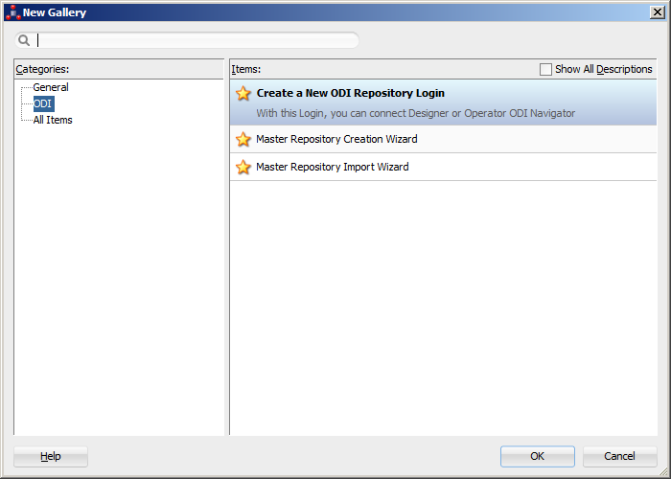](http://blog.3sixty-analytics.com/wp-content/uploads/2014/04/ODI_StandAlone52.png)

Then enter the connection details to the Repository – the supervisor user/password as entered when creating the domain (note the user SUPERVISOR must be entered in uppercase) and the DEV_ODI_REPO being one of the schemas created by the RCU above (change the prefix DEV if required)

Note the Login Name for supervisor is just a text name referring to the supervisor user-id, it’s not the user-id itself which is on the next line. You could enter any text into this field.

It’s also worth selecting the Work Repository to connect to at this point as well – otherwise you’ll only have to manually select it each time you connect. Use the Magnifying glass icon next to the Work Repository field for this. This is also a good test of the connection details already entered – it will error if the user-id or password for Supervisor is wrong.

[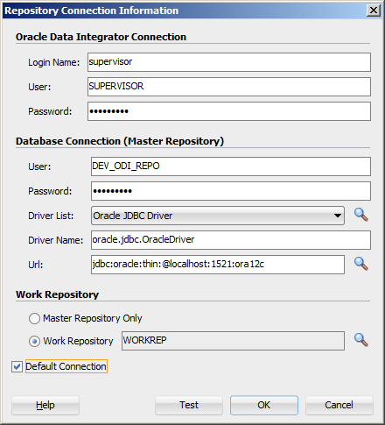](http://blog.3sixty-analytics.com/wp-content/uploads/2014/04/ODI_StandAlone53.png)

Click test just to make sure!

[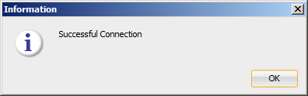](http://blog.3sixty-analytics.com/wp-content/uploads/2014/04/ODI_StandAlone54.png)

ODI uses a wallet to store encrypted connection details – using this means you only need to enter the wallet password each time you connect rather than individual passwords for the master & work repositories and other components. So enter a password for the wallet.

The 18,000 days I entered for expiry is probably a little OTT, but this is only a dev install!  You can store the passwords without a secure wallet, but I can’t think of a benefit in doing so unless you intend to forget your password or are particularly lazy…even in a development environment you should have some security on your work.

[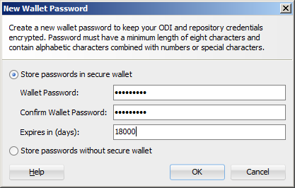](http://blog.3sixty-analytics.com/wp-content/uploads/2014/04/ODI_StandAlone55.png)

Now back at the main ODI screen, click Connect to Repository….which we’ll be doing every time we launch ODI. Enter the new Wallet password:

[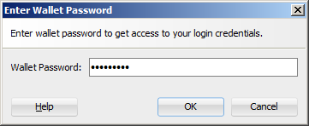](http://blog.3sixty-analytics.com/wp-content/uploads/2014/04/ODI_StandAlone56.png)

Then in the ODI login screen the user/password details are pre-filled out for us, so just click OK to connect.

[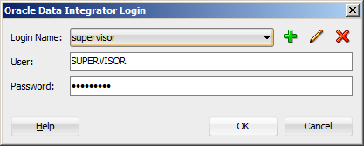](http://blog.3sixty-analytics.com/wp-content/uploads/2014/04/ODI_StandAlone58.png)

**Connecting to the Agent in ODI 12c**

Now that you are connected to the repository we can configure the Agent connection.

Click on the Topology tab of the navigator window then right click on Agents and select New Agent:

[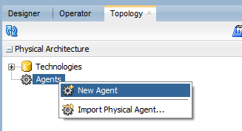](http://blog.3sixty-analytics.com/wp-content/uploads/2014/04/ODI_StandAlone59.png)

In the new tab that opens up enter the Agent Name (the system component name when installing the Agent above), e.g. OracleDIAgent1,the name of the host server and the port on which the Agent listens – specified above when installing the Agent:

[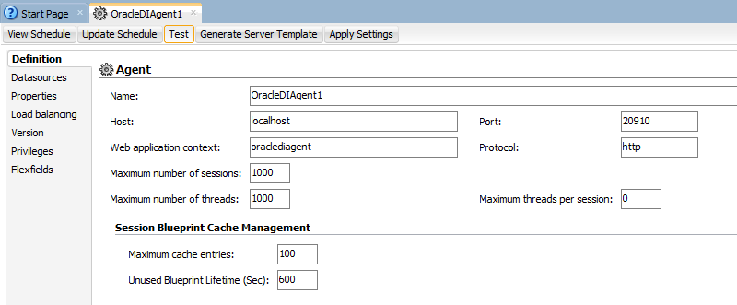](http://blog.3sixty-analytics.com/wp-content/uploads/2014/04/ODI_StandAlone60.png)

All other values can be left as default. Click the Test button in the menu bar of the tab.

[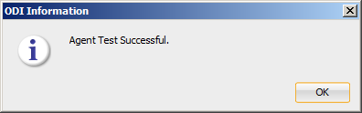](http://blog.3sixty-analytics.com/wp-content/uploads/2014/04/ODI_StandAlone61.png)

Then click Apply Settings to save and close the Agent details tab.

So that’s it, ODI is now fully installed and ready to use.

Enjoy!